Sales Accessory Maintenance

Before you can sell a sales accessory, you have to first create it through Sales Accessory Maintenance (See Figure 1) from the Rate Control menu. This screen allows for the definition of sales accessories and their associated fees and taxes. The sales accessory’s price may also be defined by location. These accessories can be referenced for use in contracts and reservations.

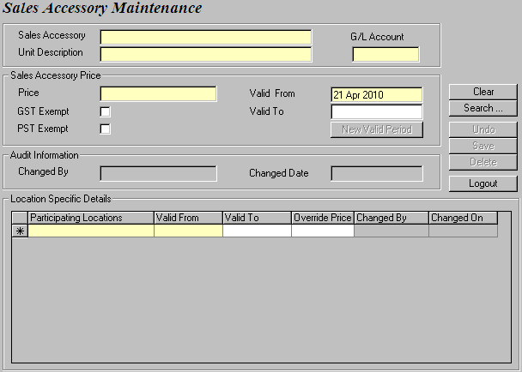
Figure 1: The Sales Accessory Maintenance screen.

Start creating your sales accessory by populating the Sales Accessory, Unit Description, Price, Valid From and To fields. You can also specify whether the sales accessory is exempt from GST or PST. The G/L Account follows a naming convention of 1234-XX-YY where XX indicates that it is location-based and YY, an optional suffix, indicates that it is vehicle-class-based.

Next, you may enter location specific information for your sales accessory. The locations that offer the sales accessory are added to the Participating Locations column. Then for each participating location, you can define a location specific price in the Override Price field. This new amount will override the Price you previously set in the Sales Accessory Price section. Audit information is visible for each sales accessory and for each participating location. Save all your changes.

To retrieve a sales accessory for modification, you can search by using the Sales Accessory name, Unit Description, or Valid From and To dates.

